Analyzing Mass Spectrophotometer Results

**Preparing the files for the analysis:**

All files need to be saved on the desktop or in a folder:

* All names should be in English.
* Make sure there is no space between words in the file name.
* Convert files to mzML files while using the MSConvert application, for downloading: <https://proteowizard.sourceforge.io/download.html>

Once you download the app:

1. Click Browse and select file(s) for conversion. Then click Add to add them to the MSConvert workflow.
2. Choose an Output Directory.
3. Under Options, choose mzML.
4. Under filters, choose Peak Picking with Vendor checked, in order to centroid the data. Indicate MS-Levels 1-2. Click Add to add the filter.

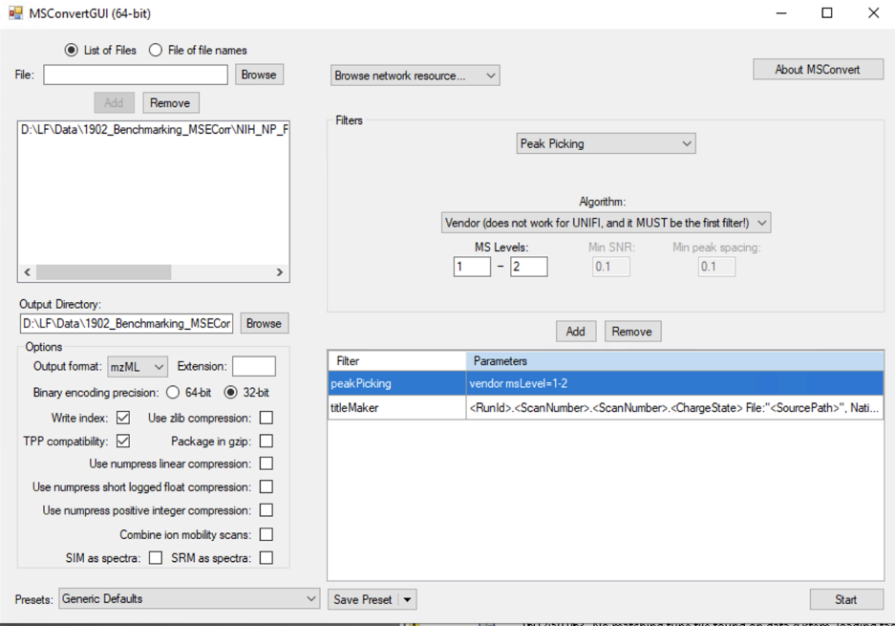

* Upload the files via WinScp to gnsp:
* To download Winscp: <https://winscp.net/eng/download.php>
* Create a user at: <https://gnps.ucsd.edu/ProteoSAFe/static/gnps-splash.jsp>
* Sign in to Winscp using your gnsp user as follows:

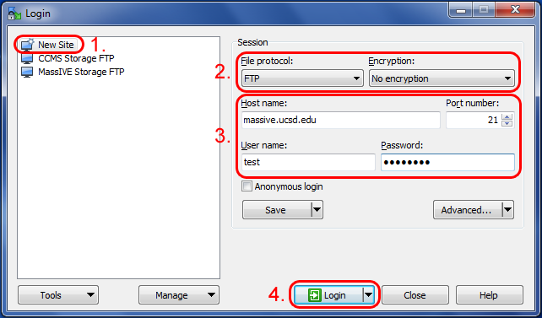

From here, you can upload files by finding them on your computer (usually in the left panel) and then dragging them over to the server (usually in the right panel).

* Another application to help visualize the data is compass dataanalysis

**Analyzing the data in GNPS:**

Please note that different jobs should be run one after the other, those jobs are then used (via the link)- see below.

At this stage there are 2 ways to look at the data:

* 1. As a metadata sheet
  2. As groups

1.Metadata file:

You need to prepare a google datasheet or follow this:

<https://ccms-ucsd.github.io/GNPSDocumentation/metadata/>

* The first column should be “filename”, this title gnps does understand

Make sure the file names is just as the files uploaded in gnps, otherwise it will not read it.

* The other columns should be “ATTRIBUTE_addwhatever”

Make sure there is no spaces, and is in English

* **Each file should end with “.mzML”**
* In GNPS, you need to choose spectrum files.

For this analysis, I named the files as follows:

|  |  |  |  |  |  |
| --- | --- | --- | --- | --- | --- |
| Metabolome type of interests | Major component | 1:4 DOM amendment | 0 h | 72 h | File name |
| Cell biomass | Prochlorococcus MIT9313 | Pro99 medium | √ | √ | CB_Pro99_T0_(1-3)/ CB_Pro99_T72_(1-3) |
| MIT9313 lysate |  | √ | CB_MIT9313_lysate_(1-3) |
| MIT9313 P-SS2 viral lysate |  | √ | CB_P-SS2_(1-3) |
| MIT9313 Syn19 viral lysate |  | √ | CB_Syn19_(1-3) |
| MIT9313 extracellular filtrate |  | √ | CB_EF_(1-3) |
|  | MIT9313 lysate | -- | √ |  | L_MIT9313_lysate_(1-3) |
| Lysates | MIT9313 P-SS2 viral lysate | -- | √ |  | L_P-SS2_(1-3) |
|  | MIT9313 Syn19 viral lysate | -- | √ |  | L_Syn19_(1-3) |
|  | MIT9313 extracellular filtrate | -- | √ |  | L_EF_(1-3) |

- Once the google sheet is ready, copy the link and paste it here:

|  |
| --- |
|  |

All other parameters should be set as shown above.

2. As groups (see supplementary for more details regarding the groups):

- Go to molecular network 🡪 create 🡪 choose a title

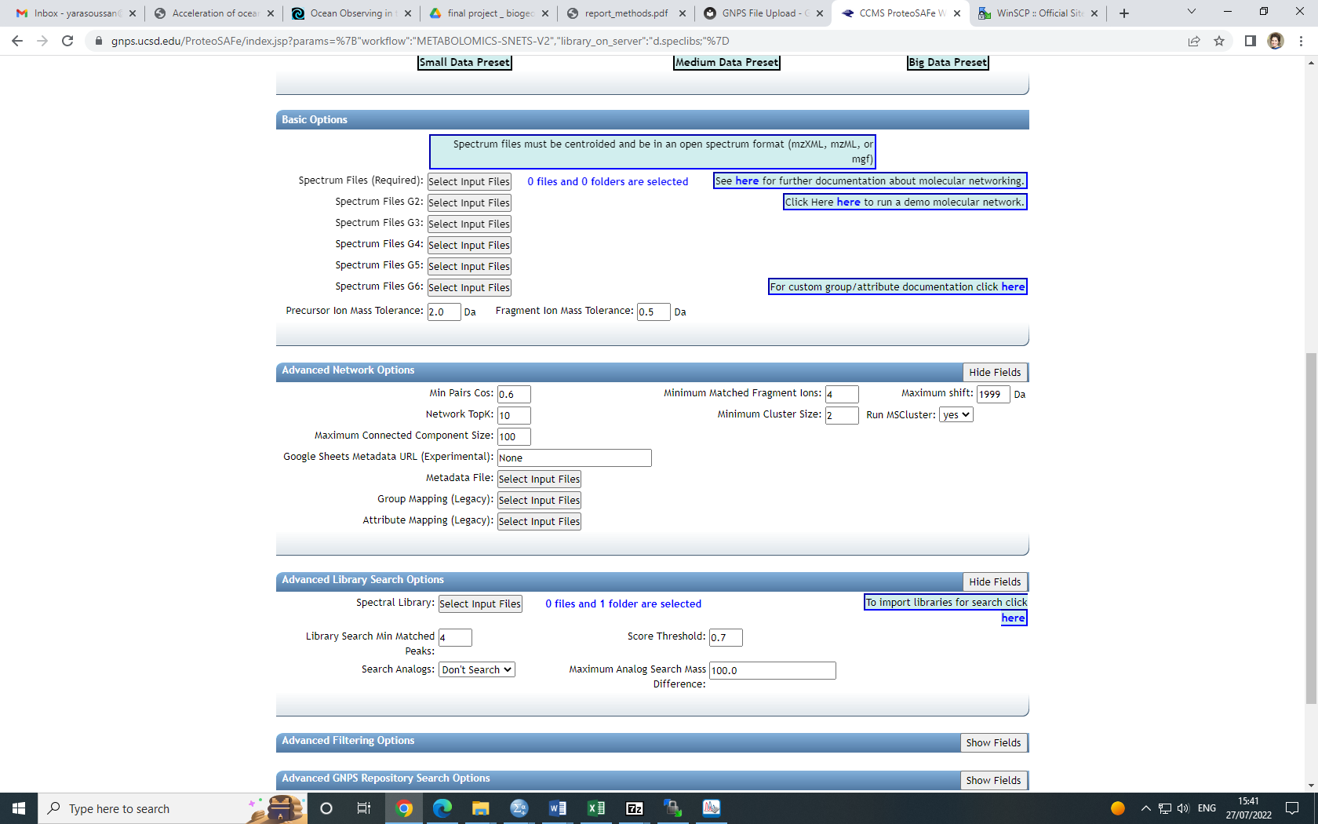- basic options: here you upload the files as groups. In advanced network options, make sure you choose as shown in the picture below:

* Submit, once the run is over a message will be sent to the email address you added.
* Once the first job is over, go to the link and choose “analyze with MS2LDA”, it will run and an email will be received once it is over, (see below).
* Also run “Annotate with DEREPLICATOR” from the first job link, (see below).

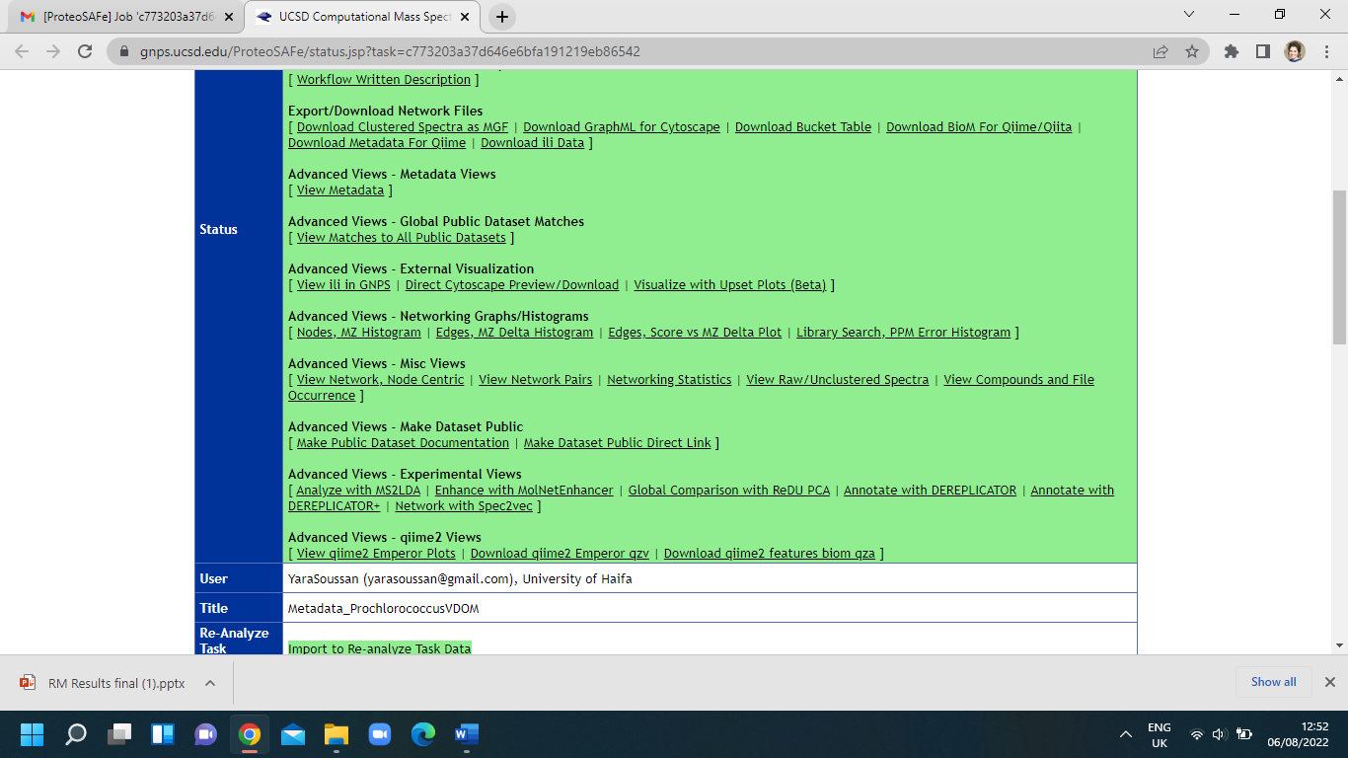

* Once the jobs are done, you go to the main job (the first one) and choose “enhance with molnetenhancer”
* You will reach this page:

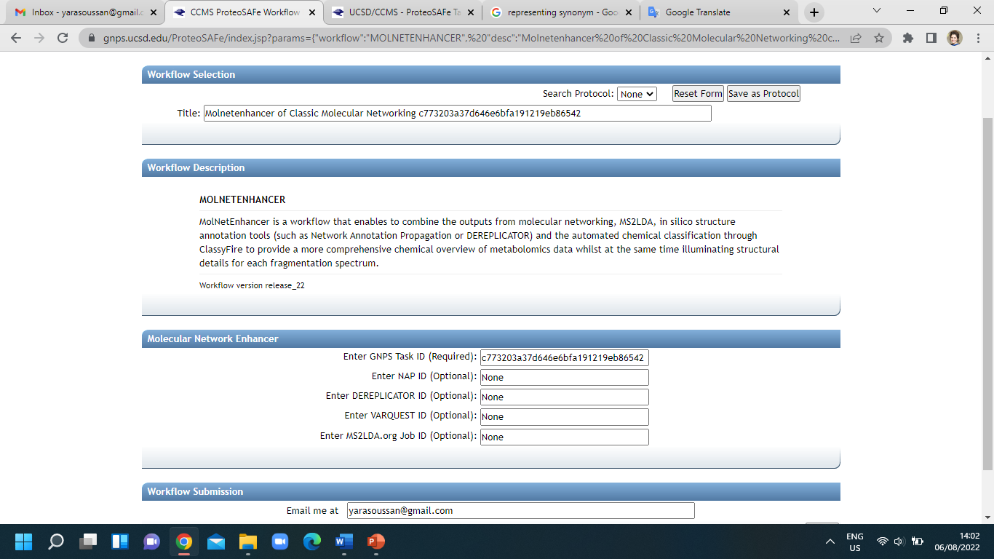

* You need to copy the IDs of the tasks from the “job” list and paste them as shown above, then submit the job.

**Cytoscape analysis:**

To quickly get started with your molecular network in Cytoscape, we have an easy export module from GNPS that previews the molecular network and provides a pre-formatted Cytoscape file. From the status page, click the "Direct Cytoscape Preview/Download"

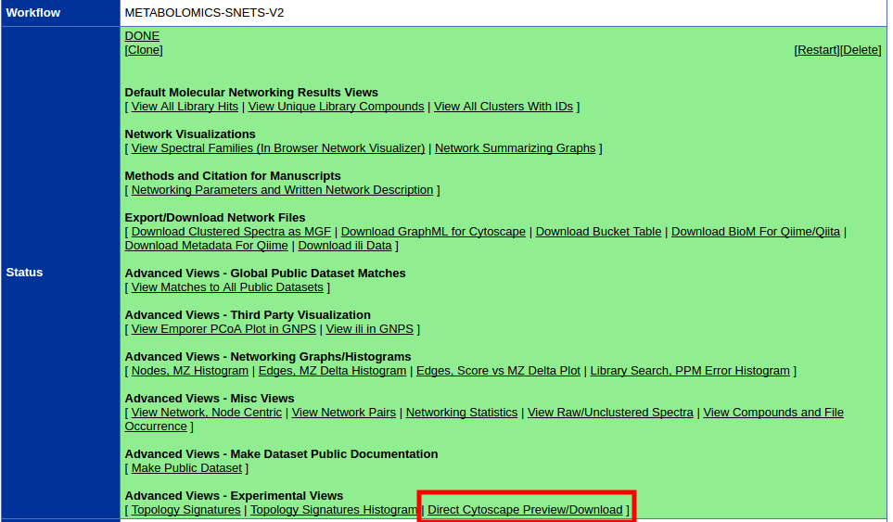

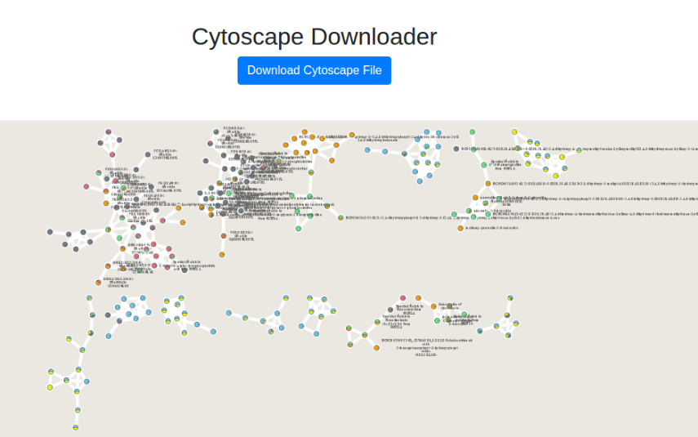This will bring you to a new interface where you will see a preview and a download link.

The first step is to download the correct input to import into Cytoscape. From the results page of molecular networking, you will need to download the graphML file for Cytoscape.

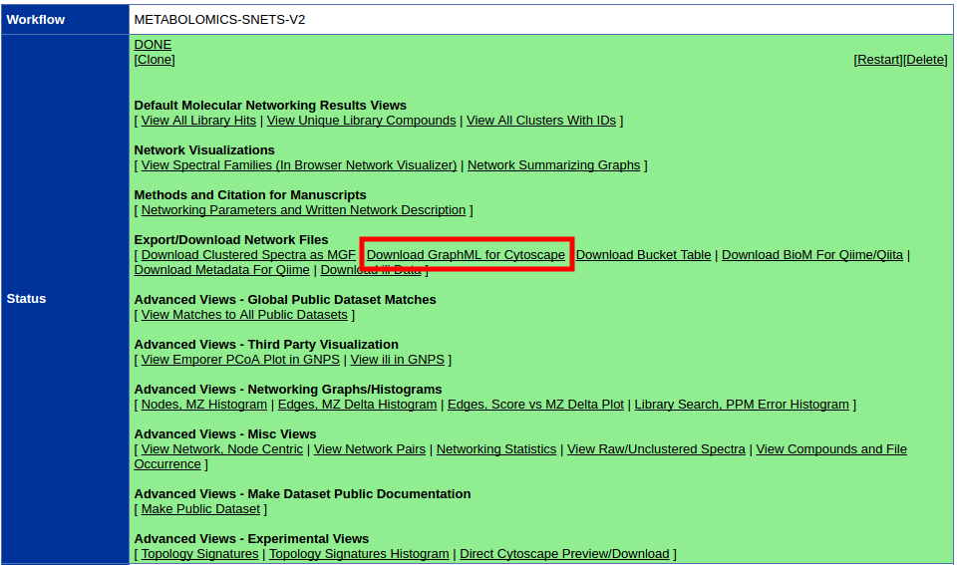

Unzip the content of the zip file. The content will look like this:

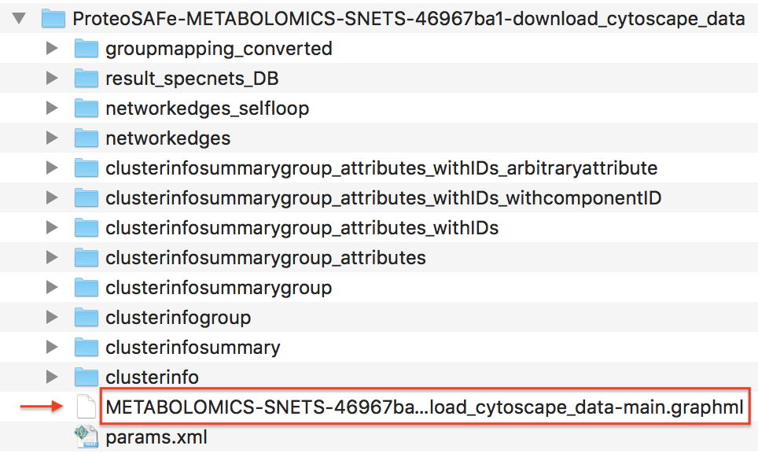

Importing Network into Cytoscape

Now open Cytoscape 3.6.1. From the Toolbar go to File / Import / Network / File (or cmd + L) and then select the .graphml file in the root of the unzipped job folder.

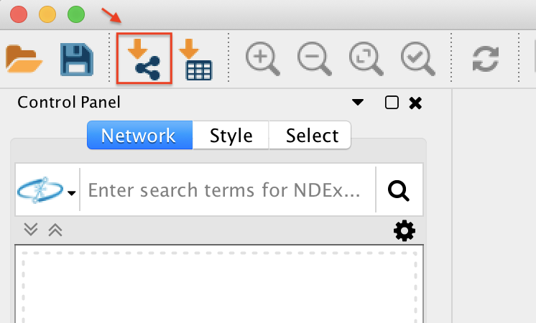

The network has been opened and will look like this.

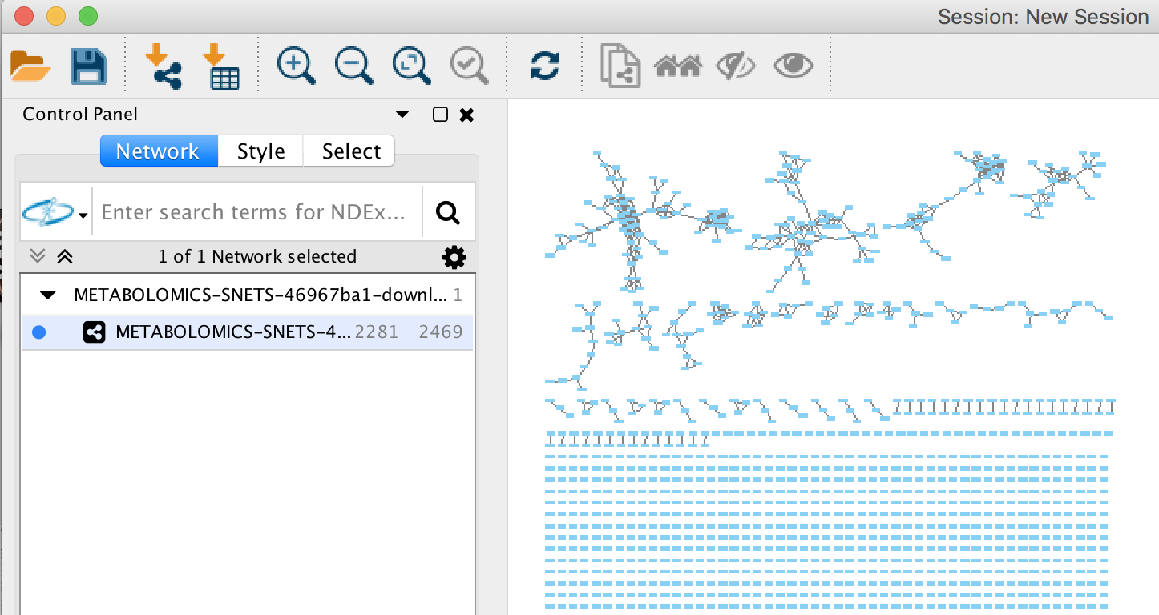

**Supplementary:**

When running in groups, two separate networks were defined:

1. All the samples for cell biomass, divided into 6 groups as shown below:

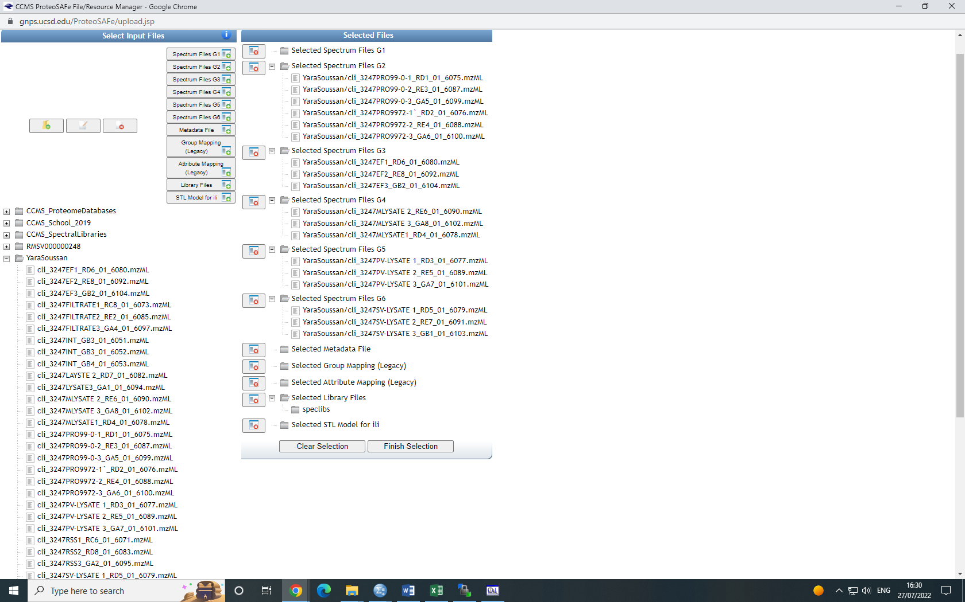

1. All the samples from the lysate:

